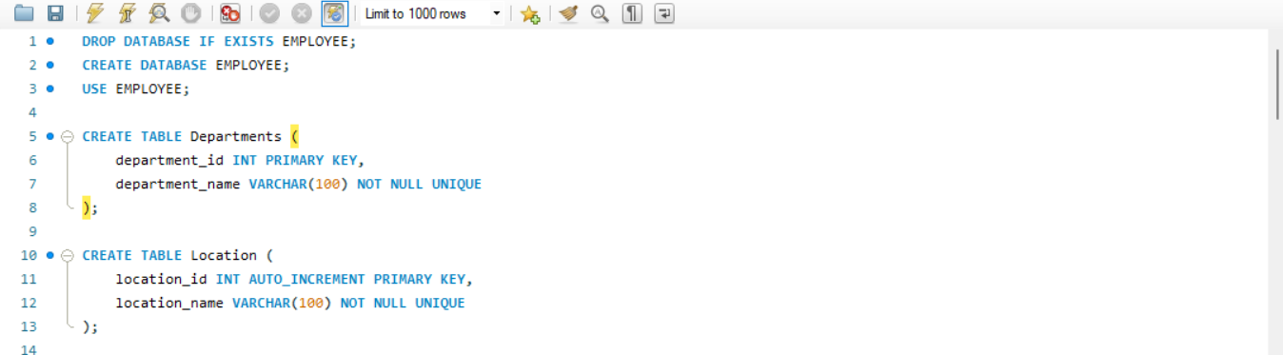
PAGE 1)

Step 1:
Delete old databaseDROP DATABASE IF EXISTS EMPLOYEE;If EMPLOYEE database already exists, delete it so you start fresh. If it doesn't exist, no error.Step
2: Create new databaseCREATE DATABASE EMPLOYEE;Created a new empty database named EMPLOYEE.Step
3: Select the databaseUSE EMPLOYEE;Told MySQL to work inside the EMPLOYEE database for all next commands.Step
4: Create Departments tableCREATE TABLE Departments ( ... );department_id INT PRIMARY KEY - Unique ID for each department, cannot repeat, cannot be empty.department_name VARCHAR(100) NOT NULL UNIQUE - Department name, up to 100 characters, must be given, cannot repeat.Step
5: Create Location tableCREATE TABLE Location ( ... );location_id INT AUTO_INCREMENT PRIMARY KEY - Unique ID, automatically increases 1, 2, 3... you don't need to type it.location_name VARCHAR(100) NOT NULL UNIQUE - Location name, up to 100 characters, must be given, cannot repeat.In short:

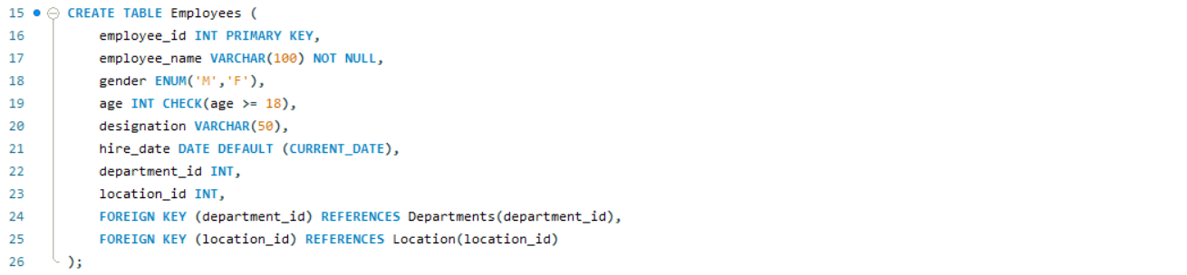
PAGE 2)

Steps Followed:Step
1: First, I deleted the existing EMPLOYEE database if it was already present, to avoid any errors and to start with a fresh database.Step
2: Then, I created a new database named EMPLOYEE.Step
3: After that, I selected the EMPLOYEE database to work inside it.Step
4: Next, I created the Departments table to store department details. In this table, department id is kept as the primary key and department name is kept as unique and mandatory.Step
5: Then, I created the Location table to store location details. In this table, location id is kept as the primary key and it is set to generate automatically, and location name is kept as unique and mandatory.Step
6: Finally, I created the Employees table to store employee details like employee id, employee name, gender, age, designation and hire date. The age is set to accept only 18 and above. The hire date is set to take the current date automatically if not given. The department id and location id are linked as foreign keys from the Departments and Location tables.Result:The EMPLOYEE database was successfully created with Departments, Location and Employees tables.

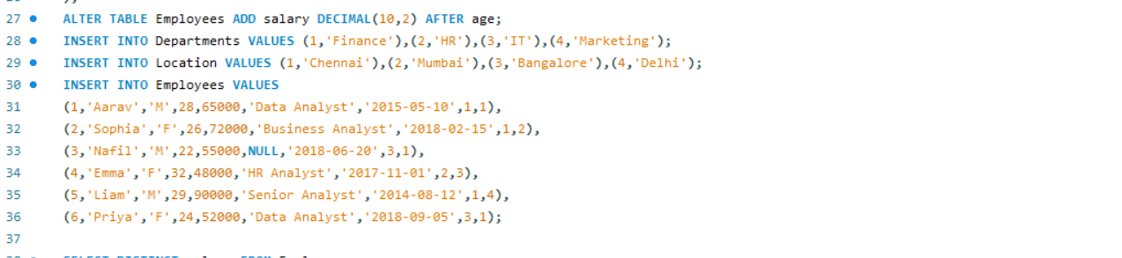
PAGE 3)

Step 7: After creating the tables, I modified the Employees table and added a new column for salary after the age column. The salary is set to store decimal values.Step
8: Then, I inserted four department records into the Departments table. The departments inserted are Finance, HR, IT and Marketing.Step
9: Next, I inserted four location records into the Location table. The locations inserted are Chennai, Mumbai, Bangalore and Delhi.Step
10: Finally, I inserted six employee records into the Employees table. For each employee, I entered the employee id, employee name, gender, age, salary, designation, hire date, department id and location id.The employees inserted are Aarav, Sophia, Nafli, Emma, Liam and Priya.Result:The salary column was successfully added to the Employees table, and all the department, location and employee records were successfully inserted.

PAGE 4)
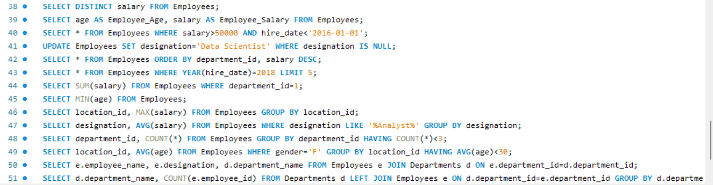
Step 11: Then, I displayed the different salary values from the Employees table without any repetition.Step
12: Next, I displayed the age and salary of all employees, by showing age as Employee Age and salary as Employee Salary.Step
13: After that, I displayed the details of employees whose salary is more than 50000 and who joined before 1st January 2016.Step
14: Then, I updated the designation of employees whose designation was empty, and set it as Data Scientist.Step
15: Next, I displayed all employee details arranged by department id, and inside each department, arranged by salary from highest to lowest.Step
16: After that, I displayed the details of employees who joined after the year 2018, limited to only five records.Step
17: Then, I calculated the total salary of all employees belonging to department id 1.Step
18: Next, I found the minimum age among all the employees.Step
19: After that, I found the maximum salary in each location, by grouping the employees location wise.Step
20: Then, I calculated the average salary for each designation, but only for designations that contain the word Analyst.Step
21: Next, I counted the number of employees in each department, and displayed only those departments which have more than three employees.Step
22: After that, I calculated the average age of female employees in each location, and displayed only those locations where the average age is more than 30.Step
23: Then, I displayed the employee name, designation and department name of all employees by joining the Employees table with the Departments table.Step
24: Finally, I displayed the department name along with the number of employees in each department, by joining the Departments table with the Employees table, so that even departments with no employees are also shown.Result:All the retrieval, updation, grouping and joining operations were performed successfully on the Employees table

PAGE 5)


